Comparison Testing: E-vox vs Ivazz Card Design
- IVAZZ Card: ivazzcard.com
- E-Vox: sanjeevrae.github.io/Evox

- ChatGPT
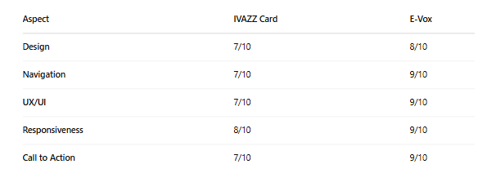

- DeepSeek

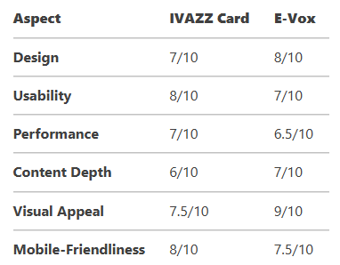

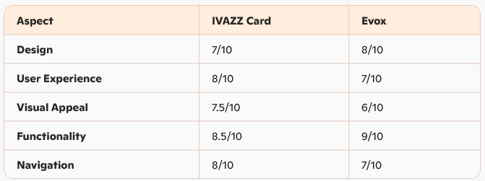
- Copilot

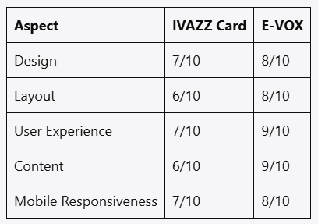
- Poe
In conclusion, E-Vox excels in design, functionality, and content depth, while Ivazz Card stands out for its user experience and mobile responsiveness.

Final Ranking:
- E-Vox: 8/10
- IVAZZ Card: 7.5/10

